Web Servers

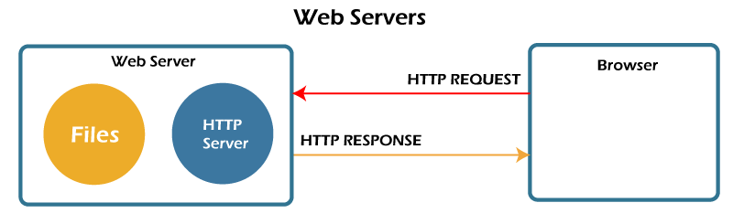

Web pages are a collection of data, including images, text files, hyperlinks, database files etc., all located on some computer (also known as server space) on the Internet. A web server is dedicated software that runs on the server-side. When any user requests their web browser to run any web page, the webserver places all the data materials together into an organized web page and forwards them back to the web browser with the help of the Internet. Therefore, we can conclude that: -

A web server is a dedicated computer responsible for running websites sitting out on those computers somewhere on the Internet. They are specialized programs that circulate web pages as summoned by the user. The primary objective of any web server is to collect, process and provide web pages to the users.

This intercommunication of a web server with a web browser is done with the help of a protocol named [**HTTP (Hypertext Transfer Protocol).**](https://www.javatpoint.com/computer-network-http) These stored web pages mostly use static content, containing [HTML](https://www.javatpoint.com/html-tutorial) documents, images, style sheets, text files, etc. However, **web servers can serve static as well as dynamic contents**. Web Servers also assists in emailing services and storing files. Therefore it also [uses SMTP (Simple Mail Transfer Protocol)](https://www.javatpoint.com/simple-mail-transfer-protocol) and [FTP (File Transfer Protocol)](https://www.javatpoint.com/computer-network-ftp) protocols to support the respective services. Web servers are mainly used in web hosting or hosting the website's data and running web-based applications.

The [hardware](https://www.javatpoint.com/hardware) of the web servers are connected to the Internet that manages the data exchange facility within different connected devices. In contrast, the software of web server software is responsible for controlling how a user accesses delivered files. Typically, web server management is an ideal example of the client/server model. Therefore, **it is compulsory for all computers that host websites (whether with state or dynamic web page content) to have web server software.**

How do web servers work?

The term web server can denote server hardware or server software, or in most cases, both hardware and [software](https://www.javatpoint.com/software) might be working together.

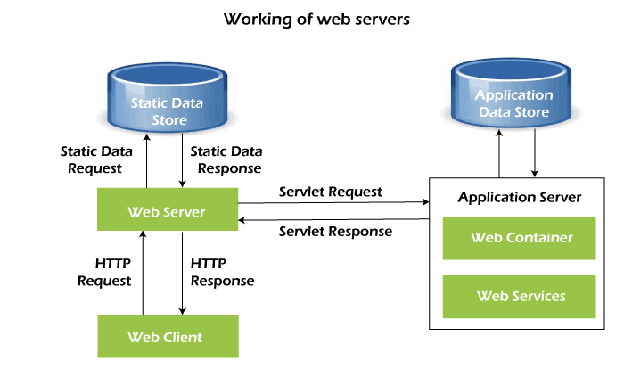

1. ***On the hardware side***, a web server is defined as a computer that stores software and another website raw data, such as HTML files, images, text documents, and JavaScript files. The hardware of the web servers are connected to the web and supports the data exchange with different devices connected to the Internet.
2. ***On the software side***, a web server includes server software accessed through website domain names. It controls how web users access the web files and ensures the supply of website content to the end-user. The web server contains several components, including an HTTP server.

Whenever any [web browser](https://www.javatpoint.com/browsers), such as [Google Chrome](https://www.javatpoint.com/google-chrome), Microsoft [Edge](https://www.javatpoint.com/edge-full-form) or [Firefox](https://www.javatpoint.com/mozilla-firefox), requests for a web page hosted on a web server, the browser will process the request forward with the help of HTTP. At the server end, when it receives the request, the [HTTP](https://www.javatpoint.com/http-tutorial) server will accept the request and immediately start looking for the requested data and forwards it back to the web browser via HTTP.

Let's discover the step-by-step process of what happens whenever a web browser approaches the web server and requests a web file or file. Follow the below steps:

1. First, any web user is required to **type the URL of the web page in the address bar** of your web browser.
2. With the help of the URL, your **web browser will fetch the IP address of your domain** name either by converting the URL via DNS (Domain Name System) or by looking for the IP in cache memory. The IP address will direct your browser to the web server.
3. After making the connection, the **web browser will request for the web page from the web server** with the help of an HTTP request.
4. As soon as the web server receives this request, it immediately **responds by sending back the requested page** or file to the web browser HTTP.
5. If the web page requested by the **browser does not exist or if there occurs some error in the process**, the web server will return an error message.
6. If there occurs no error, the browser will successfully display the webpage.